**STUDENT ATTENDANCE MANAGEMENT SYSTEM**



A project report submitted to Rajiv Gandhi Proudyogiki Vishwavidhyalaya, Bhopal towards partial fulfillment of the degree of

**MASTER OF COMPUTER APPLICATION**

**(2nd YEAR)**

**Guided By: Submitted By:**

Mr. Upendra Singh Khushbu Dashore

Department of I.T. (0801CA191012)

Department of Computer Technology & Applications

**SHRI G.S. INSTITUTE OF TECHNOLOGY AND SCIENCE**

**INDORE (M.P.)**

**SHRI G.S. INSTITUTE OF TECHNOLOGY AND SCIENCE, INDORE (M.P.)**



**Recommendation**

The project report entitled **“*Student Attendance Management System*”** submitted by **Khushbu Dashore**, students of MCA second year in the session 2020-21, towards partial fulfillment of the degree of **Master of Computer Applications** of Rajiv Gandhi Proudyogiki Vishwavidhyalaya, Bhopal, is a satisfactory account of her work and is recommended for the award of degree**.**

**Mr. Upendra Singh Head**

Project GuideDepartment of Comp. Tech. Department of Computer Tech. & Application

& Application

**Dean(Academics)**

**S.G.S.I.T.S.,Indore**

**SHRI G.S. INSTITUTE OF TECHNOLOGY AND SCIENCE, INDORE (M.P.)**



**Certificate**

The project report entitled **“*Student Attendance Management System*”** submitted by **Khushbu Dashore,** students of MCA second year in the session 2020-21, towards partial fulfillment of the degree of **Master of Computer Applications** of Rajiv Gandhi Proudyogiki Vishwavidhyalaya, Bhopal, is a satisfactory account of her work and is approved for award of the degree.

**Internal Examiner**

**Date-**

**Acknowledgement**

We are heartily pleased to acknowledge all those people who have helped us in the successful completion of this project. With great pleasure we express our heartfelt gratitude to our esteemed guide, **Mr. Upendra Singh** Lecturer Department of Computer Technology & Application, S.G.S.I.T.S. Indore. Her persistent encouragement, perpetual motivation, everlasting patience and valuable technical inputs in discussions have enabled the successful completion of this project. Her invaluable help, advice and constant encouragement helped us a lot and provide impetus to the progress of the project. We extend our profound indebtedness to the Head of the department **Ms. Sunita Varma,** the word loose their worth for her invaluable guidance, continuous encouragement and cooperation in every respect.

We sincerely wish to express our gratitude to all the members of staff of M.C.A.who have extended their cooperation at all times and have contributed in their own way in developing the project. Successful completion of a project is not an individual effort. It is an outcome of the cumulative effort of a number of persons, each having his own importance to the objective. We are thankful to our parents for being a constant source of encouragement in all our endeavors. Indeed it is their support that helps us through the ups and downs of life. The support and suggestion of our friends are worth appreciation and thankfulness.A blend of gratitude, pleasure, great satisfaction and indebtedness is what, we feel to convey to all those who have directly or indirectly contributed to the successful completion of our project work.

**Khushbu Dashore 0801CA191012**

**Introduction**

Student Attendance Management System project is developed for daily attendance of students in school, colleges and institutes. It facilitates to access the attendance information of students for a particular subject(java or operating system) .

It gives the information of average attendance of students in a particular subject. Attendance will be provided by user for a particular subject. This is a terminal based project.

The intention of developing attendance management system is to computerized the traditional way of taking attendance of students for a particular subject.

* **When you choose ‘j’ (java as subject):-**

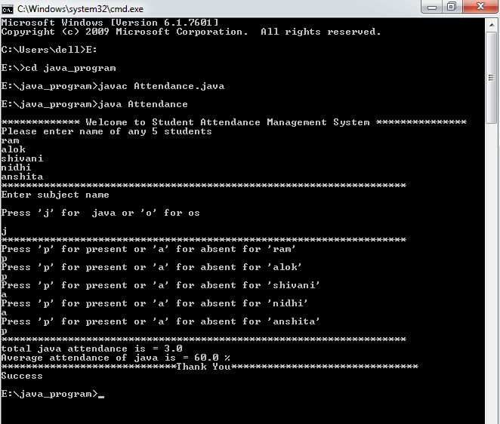

* **When you choose ‘o’(operating system as subject):-**

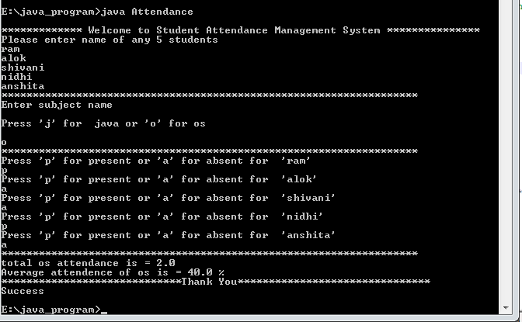

* **When nothing is choosen between java and operating system(when user gives wrong input):-**

